PROJECT PROPOSAL

OBJECT ORIENTED PROGRAMMING

SUBMITTED BY:

MUHAMMAD MIQDAD AHMED BSCE22001

MARYAM AFTAB BSCE22031

MAHEEN BSCE22018

PROJECT TITLE:

**LOGIN AND REGISTRATION SYSTEM**

**CHESS GAME**

**WORKING:**

**1)LOGIN AND REGISTRATION SYSTEM:**

**FUNCTION:**

In this system we will store the data of all the users who want to play the game. They will either log in as guest or make an account. In the case of guest no data will be saved but in case the player decides to make an account then we will create a file with the name of the user. Then we will store the data of the user in it. The data that will be stored is:

1. Name
2. Password
3. Number of games played.
4. Number of games won.
5. Number of games lost.
6. Rank.

**2)CHESS GAME:**

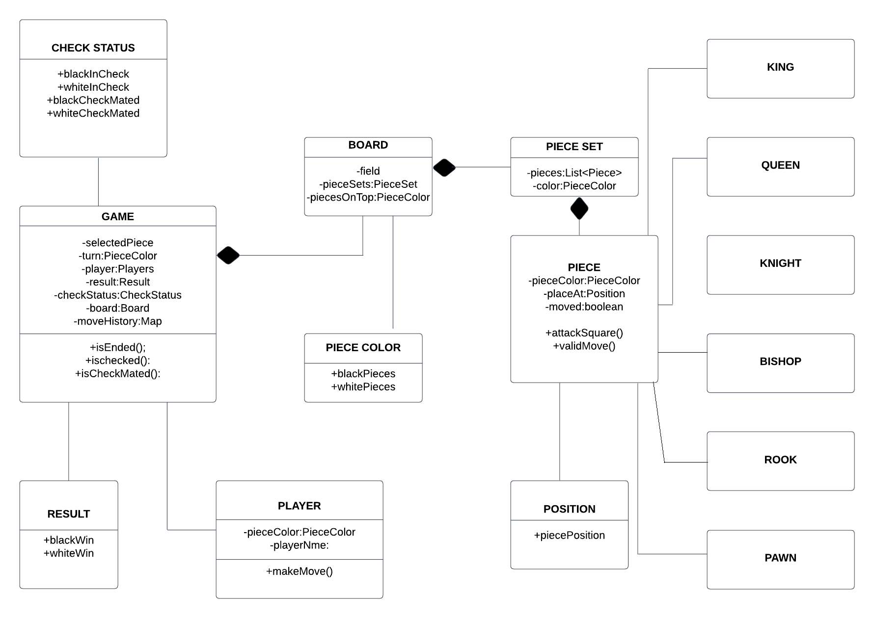

**FUNCTION**

Chess is a game played between two opponents on opposite sides of a board containing 64 squares of alternating colors. Each player has 16 pieces: 1 king, 1 queen, 2 rooks, 2 bishops, 2 knights, and 8 pawns. The goal of the game is to checkmate the other king.